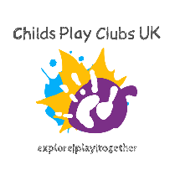
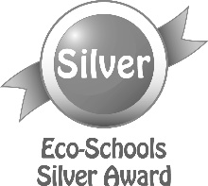

Vallis First School Newsletter
Autumn – Thursday 17th September 2020
www.vallisfirstschool.org
It has been a very busy week getting used to all the new routines but it has felt more like a school and learning environment which has been great. We have already tweaked some of our plans and we will be observing how things work all the time and adapt as needed – we will of course keep you informed if anything changes.

Our website has undergone a few changes over the past few months and we will be continuing to update and improve it as we progress through the year – keep an eye on the gallery as we are uploading new pictures all the time. Can I also remind parents that the VSA page is primarily about the events and fundraising of the parent association. If you have any queries about school, these should be directed to your child’s class teacher or the school office please.

Our first Star Powerful Learners of the year are: Genevieve from Neptune; Olivia from Apollo; James from Jupiter; Logan from Saturn; Vinnie from Galaxy; Isla from Milky Way and Ermelina from Mars. Well done to you all.

Nick Firkins
Headteacher
Sun and Moon Classes are looking for welly donations for their Foundation Stage children so they can play outside, whatever the weather!
If you have a of pair of wellies size 8-11 you would like to donate, please drop them into the box by the Foundation Stage entrance gate.

Thank you, Sun and Moon classes team.

Parent Governor Vacancy: If any parents are interested in joining our Governing body, please contact Jacky in the school office for further information.
Casual Job vacancy: We are currently looking for someone to join our staff on a casual basis (initially) that we can train up to be a supply Lunchtime Supervisor and supply Crossing Patrol person. If you are interested in this post, please contact the school office.
VSA NEWS
We hope you all enjoyed the first week back. We are still finalising our plans for this term – look out for more news next week.

Hundred Club: Details and application forms for this year’s Hundred Club will be sent home next week when the Foundation Stage classes have started properly. However we still have a few unclaimed prizes from last year – we will publish these on the VSA Facebook page tomorrow so please take a look to check, with lockdown etc it was easy to miss!

Flu Immunisations: Please remember to register for your child to get this nasal immunisation at https://saint.sompar.nhs.uk/flu/2020/east as soon as possible.
Dates for your Diary
Wednesday 14th October (TBC) – Parents Evening
Thursday 15th October (TBC) – Parents Evening
Thursday 15th October – School photos
Friday 23rd October – Last day before half term
Monday 2nd November – Back to school

