Whole School Theme - Changes
Have fun completing some of these activities with your child/ren over the next week. Don’t forget you can still share their work in our Virtual Vallis Facebook group or email your child’s class teacher!
Star Qualities  What would you tell your new teacher about yourself?  Make a star and fill it with things you are good at or activities you enjoy.  Decorate your star | Make a ‘chatterbox’ asking a member of your family or a friend questions about their time at school. You could include question like What was your favourite subject? Did you have a favourite teacher? What didn’t you like? Did you have school dinners? | 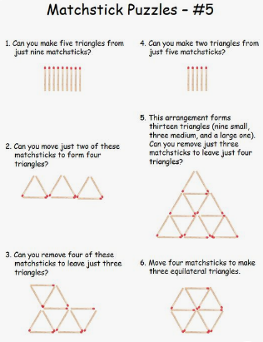  https://www.pinterest.co.uk/pin/330029478915784564/ |  | Can you plan and carry out a science investigation exploring changes of state. This could involve cooking, melting, burning or dissolving.
Find out about the lifecycle of an animal. Can you draw or represent it in a creative way? You could make models, a mobile or an animation. | Go for a walk. What changes do you notice which tell you it is summer? Take photographs, paint or draw pictures of what you notice.  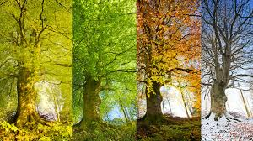 | Climate change  Can you create a model that is powered by an elastic band or wind? It could be a vehicle or a windmill.  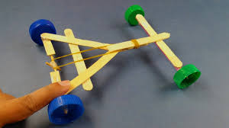 | If you would like more structure you can refer to https://www.bbc.co.uk/bitesize or https://www.thenational.academy/  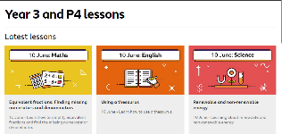  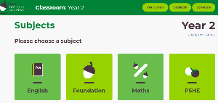  where you will find daily lessons for Maths, English and other subjects. Just click on your child’s year group.

